ONTASK v0.5
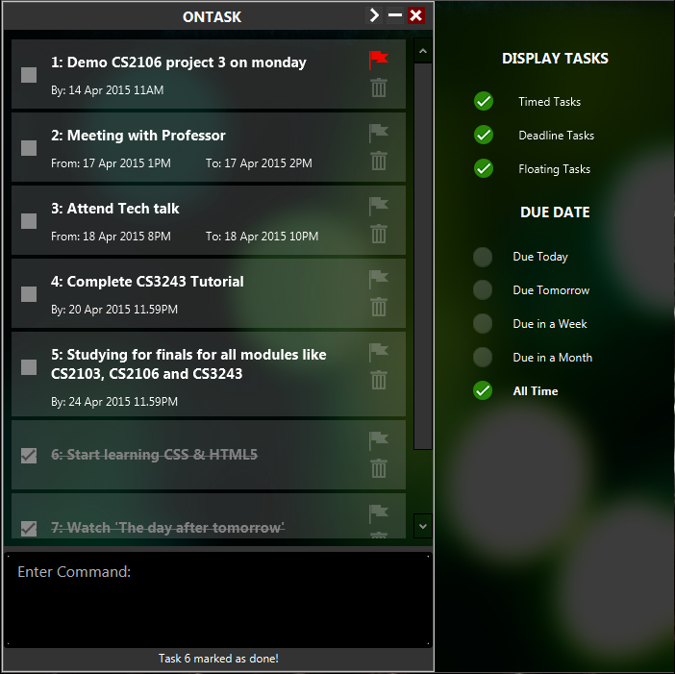
Supervisor: Ryan Extra feature: GUI
  Daren Tan  Team lead, Documentation,  Deliverables & Deadlines |   Parag Bhatnagar  Software Expert,  Integration,  Code Quality |   Wang Minwei  Testing,  Documentation,  Scheduling & Tracking,

User Guide

Welcome to ONTASK!

1. Introducing our Software

1.1. Now that you've started using our software, here is some information on beginning to use our product!

Similar to all other GTD softwares, our product will provide the fundamental needs for tracking tasks and events. Users will be able to rely on this software to increase their productivity, manage emails, tasks, projects all in one place.

The program has a simple, minimalist GUI with task adding, editing, deleting, undo/ redo functions, search and sort capabilities.

2. Getting Started

2.1. No installation is required before using our product. Just run the program to get started!

2.2. The program uses an Ontask.xml file for persistent storage and requires user to specify its directory at startup. The file contains important attributes like task description, task type, start date-time, end date-time, prioritizing, completion and index. If there is no file present, the program creates a new empty file at the specified directory.

3. Features & Functions
Accepted Time Formats:
Format | Examples
24-hour clock | 09:00, 13:00, 23:59, 01:25
12-hour clock | 9am, 1pm, 11.59pm, 1.25am
Accepted Date Formats:
Format | Examples
Day Month Year | 3 1 2015, 3-1-2015, 3/1/2015, 3 Jan 2015
Day Month | 3 1, 3-1, 3/1, 3 jan
Month Day | Jan 3, january 3
Day of week | Monday, mon, thursday, thu
Special word | today, tdy, tomorrow, tmr

3.1. For new users who require help to display a list of commands when the program is initialized.
Command format:
help or <Press F1 key>

3.2. Add a floating task by specifying description only (no date and time required).
Please use quotation marks in order to input date or time formats into task description.
e.g. add watch day after “tomorrow” with family
Command format:
add taskDescription
create taskDescription

3.3. Add a time-tasked event that requires starting date, start-time, end date and end-time
Command format:
add taskDescription <date,time>
e.g. add Chalet with friends from 30 Apr 1pm to 1 May 8pm
e.g. add Chalet with friends 30/4 13:00 1/5 20:00
e.g. add Meet professor 30 Apr 2015 3pm 5pm
e.g. add Meet professor 30 Apr 2015 3pm - 5.25pm

3.4. Add a due task that has a due date and time.
Command format:
add taskDescription by endDate endTime
add taskDescription endDate endTime

3.5. To delete a completed task, refer to index number from Task list.
Command format:
delete index

3.6. To undo or redo recent actions. Number of undo operations is up to number of operations after starting the application. Undo for search, back is not supported. Number of redo operations is up to number of undo operations. User cannot redo after executing other commands than undo and redo.
Command format:
undo or <Press CTRL+Z key>
Redo or <Press CTRL+Y key>

3.7. To edit existing task, refer to index number from Task list. Edit is possible on any parameters of an existing task, provided that the parameter was passed to the task upon initialization (a due task will not have a starttime or startdate parameter, a floating task will only have the task description parameter). User cannot change task type and is forbidden to change areas which are unspecified by its task type. Illegal operations such as making start time later than end time are disallowed.

The following parameters can be edited:
task (or) desc, startdate, starttime, enddate, and endtime
Command format:
edit parameter index newValue
e.g. edit endtime 2 12:00
edit task 3 this will be my new task description

3.8. To search for existing task, please specify a parameter to search. The search function is non case-sensitive. Once the search results are displayed, user can operate on sorted list. Press BACK_SPACE Key to go back to the main list.
Command format:
search desc keyword
search task keyword
search type floating / deadline / due / timedtask / event
search before date
search date date

3.9. To return to the task list (after search), just press enter.
Command format:
<Press Enter Key>

3.10. To mark a task as completed or unmark a task.
Command format:
mark index
done index
unmark index
undone index
togglemark index

3.11. To flag a task to take priority or unflag a task.
Command format:
flag index
prioritise index
unflag index
unprioritise index
toggleflat index

3.12. To change the directory where the Ontask.xml is stored.
Command format:
changedir or <Press F1 key>

3.13. To clear the task lists.
Command format:
clear

3.13. To exit the Ontask application.
Command format:
exit
quit

3.14. To autocomplete on or off. The auto-complete function will be activated by the <Spacebar> key when a suitable command is recognized.
Command format:
<Press LEFT-ALT key>

3.15. To enable or disable the Graphical User Interface Sidebar. Click on the > Button.
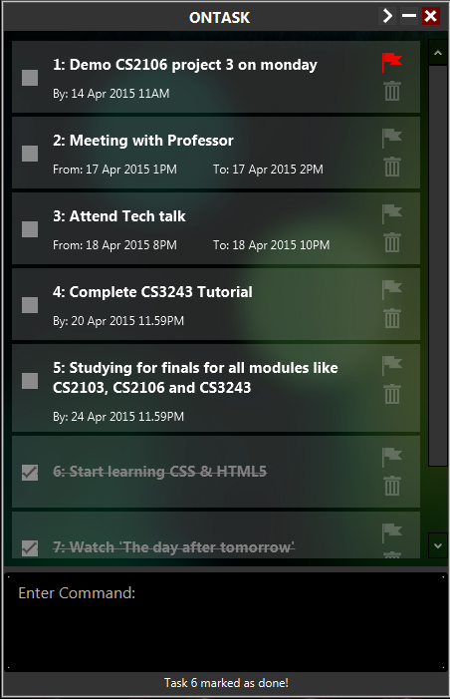

Developer Guide

4. Architecture & Components
Project Ontask relies on the top-down approach by first having an overview of the project requirements to formulate a system. It is then sub-divided into four main components: fileIO, logic, parser, gui and refined in detail base on each component. Figure below illustrates the basic architecture of how the program interacts on a component level.
4.1. The gui component is in control of the display and updating of Tasks to the graphical user interface, along with all the visual feedback and button controls.
4.2. The fileIO component will be handling the file inputs and outputs to enable reading and writing into XML for persistent storage and keeping track of the directory.
4.3. The parser component will parse the string into acceptable object-oriented formats for logic to process.
4.4. The logic component will then execute the commands accordingly and return the Task List for the GUI to re-display.
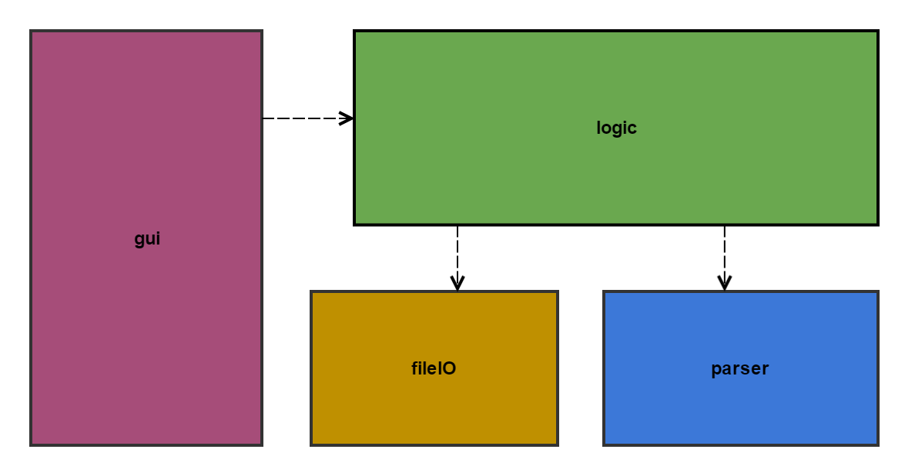
Basic architecture diagram for Project Ontask

5. Introducing the Task object
The program uses a vector of task objects of the following type with methods to get and set each attribute of the Task object. 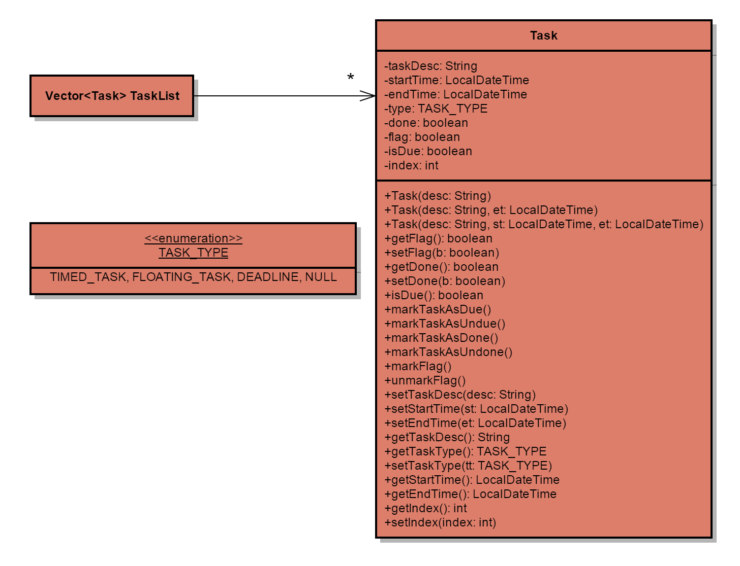
Task Class Diagram

6. Graphical User Interface
The program initializes by first running the main function of the ListViewGUI class which launches the GUI, which is made using JavaFX (http://www.eclipse.org/efxclipse/index.html).
Please mention logic uses singleton pattern
INSERT COMPONENT DIAGRAM FOR GUI, along with introducing of TaskDisplayPage.fxml and style.css in the component diagram for gui
The ListViewGUI calls the FileStream class which reads the Ontask.xml file and uses the TaskListWrapper class to create the vector of Task. The vector of Tasks is then wrapped into an observable list in TaskDisplayController which displays updates each Task in the display.
The GUI has a text area for the user to type in the string input, which is consumed upon pressing the Enter key. The string file is then sent to the parser class for parsing.

7. Parsing the string

Parser is an important component which takes user input from logic and extract meaningful information out of the string. It decides on the command type and call respective methods to perform parsing. After parsing, Parser stores extracted information in Command object and returns this to Logic class.
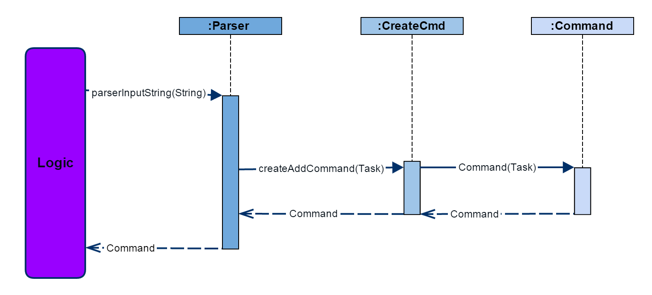
The graph above illustrates a general workflow of parsing user input string.
- Parser takes in the string file and parses it.
- Parser calls CreateCmd class with the information it extracts (Task, index, etc) to create Command object.
- Parser return Command object to logic.
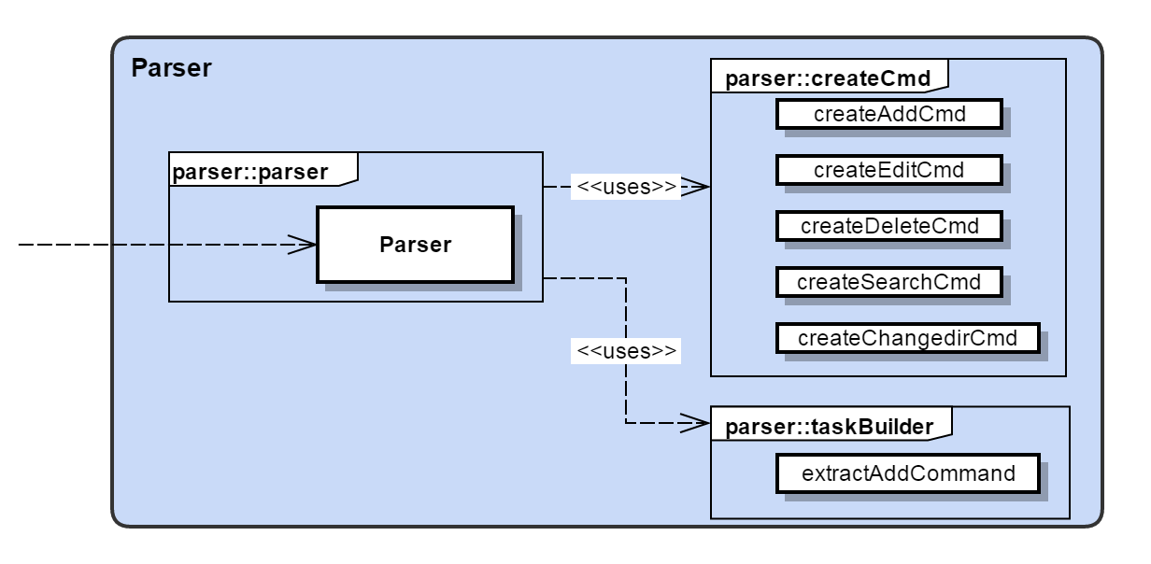
Parser class makes use of Command pattern, because it creates a Command Object for different types of operations. Thus Logic can treat them equally as Command Object and extract different information according to Command description. Parser class can be enriched with more time and date formats by defining new time/date String regex.
7.1 parsing add command
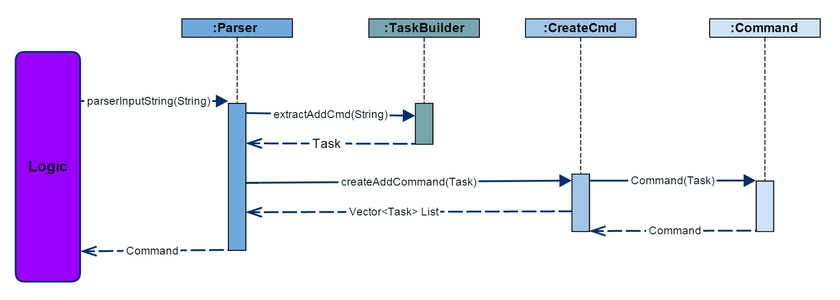
Above is a graph describing add command parsing process. It is more complex than normal parsing because our parser is able to take in more flexible formats. TaskBuilder class looks for date and time String regex in the String, and adjusts according to time indication words (by, at, from, to).
8. The Logic
The Logic component serves as a façade that sits between GUI and other components of the program. Logic takes in user input as String, passes the String to Parser, updates TaskList accordingly, and, if the operation is successful, it calls upon FileIO to store the latest version of TaskList. Logic also serves the purpose of reading from FileIO and initializes list. Logic always return a Vector of Tasks to GUI for display purpose.
The workflow of Logic is shown in the sequence diagram as followed:
- When the program first starts, UI component calls Logic to initialize list, Logic calls upon FileIO and returns a Vector of Tasks.
- In the following commands, UI calls run method in Logic to process user input.
- Logic passes the String to Parser and operates on the Command Object returned by Parser.
- After performing the operations, Logic sorts the TaskList and updates backup list by calling FileIO.
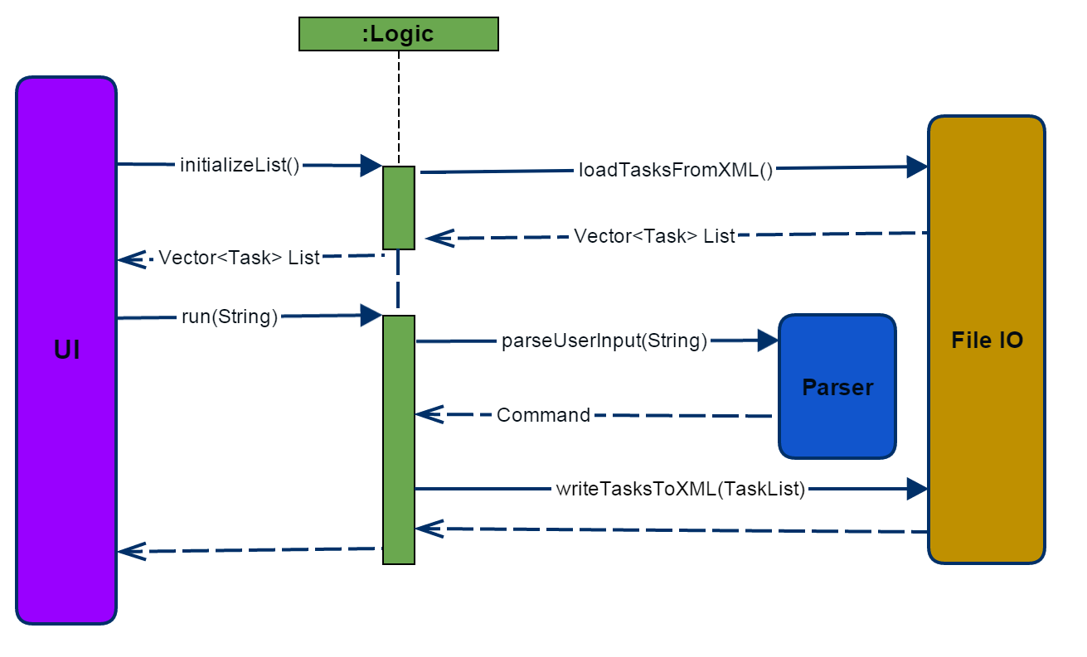
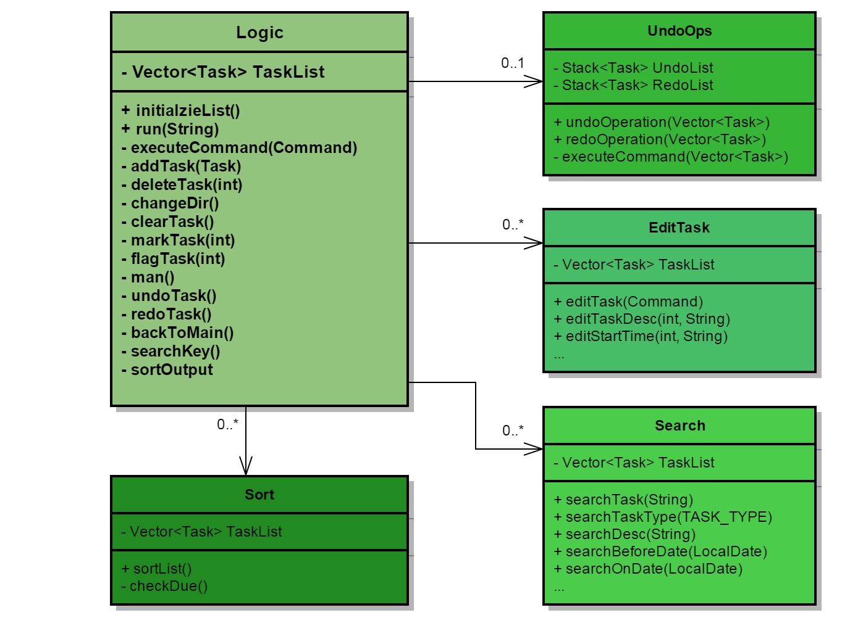
8.1 Add
For the add command, there are 3 possible Task types that can be resulted from the command, the TIMED_TASK, DEADLINE_TASK and FLOATING_TASK.
Either show the most important public method for add command or do a sequence diagram

A timed task has 3 main parameters in the form:
String taskDesc, LocalDateTime startTime and LocalDateTime endTime.

The startTime string and endTime string are sent to the timeOperator class which extracts the date and time values from the string and creates 2 new LocalDateTime objects. These LocalDateTime objects along with the task description string make up the new Task object, which is added to the vector task list.
Show a sequence diagram for the conversion?

5.4. Edit
For the edit command, there are 5 possible edit types. It is important to declare the type of edit along with the index. The EditTask class will be responsible for doing the necessary changes to the Task specified.
Show class diagram for editTask
If the edit case is task, it will only update the taskDesc attribute in the specified Task. However, it is not possible to edit a non-existent attribute in Task.
Show examples of correct / incorrect inputs for edit function.

I STOPPED HERE – daren

5.5. For the delete command, a Command object is basically passed to the executeCommand method which states the index of the task to delete. The deleteTask method takes in the index and removes the task in the TaskList vector accordingly.
public void deleteTask(int index) {
try {
if (index > 0 && index <= TaskList.size()) {
TaskList.remove(index - 1);
operator.showToUser(String.format(MESSAGE_DELETE, index));
isSuccessful = true;
} else {
operator.showToUser(String.format(MESSAGE_TASK_FAILURE, index));
}
} catch (IndexOutOfBoundsException e) {
operator.showToUser(String.format(MESSAGE_COMMAND_FAILURE, "delete"));
}
}

5.6. For search, it is currently case-sentive and uses methods searchTasks and containsText in the Logic class to return a separate vector of tasks that has the keyword/s to be re-displayed in the GUI. In order to return to the usual display of all task, we simply press enter, which consumes an empty string to return to the original task list.
public Vector<Task> searchTask(String str) {
Vector<Task> resultTaskList = new Vector<Task>();
String textContent = null;

for (int index = 1; index <= TaskList.size(); index++) {
textContent = TaskList.get(index - 1).getTaskDesc();
if (containsText(textContent, str)) {
resultTaskList.add(TaskList.get(index - 1));
}
}
operator.showToUser("keyword" + str + "searched");
isSuccessful = true;
return resultTaskList;
}

private boolean containsText(String taskcontent, String keyword) {
String[] keywords = keyword.split(" ");
for (String s : keywords) {
if (!taskcontent.contains(s)) {
return false;
}
}
return true;
}

5.7. For the undo command, we currently only have a 1-time undo implemented which stores a BackUpList in the backup method after every successful execution of command. When the undo command is initiated, we overrides the TaskList with the BackUpList to pass it to the display.
public void backup() {
BackUpList = (Vector<Task>) TaskList.clone();
}

public void undo() {
if (BackUpList != null) {
TaskList = (Vector<Task>) BackUpList.clone();
operator.showToUser("undo completed" + TaskList.isEmpty());
} else {
operator.showToUser(String.format(MESSAGE_COMMAND_FAILURE, "undo"));
}
}

9. Persistent Storage: fileIO

The fileIO component is responsible for converting the Task List to be stored in the XML and vice versa for persistent storage. It is also responsible for monitoring the directory location which includes initializing and changing of directory path.

There are two classes in fileIO, the FIlestream and TaskListWrapper. This component adheres to the single responsibility principle where each of the classes have their single responsibility entirely encapsulated within the class.
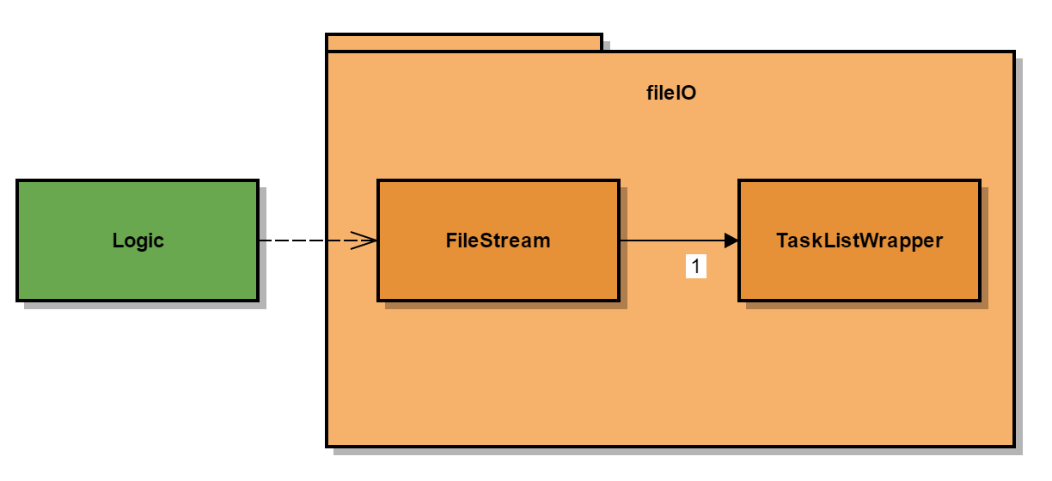

The FileStream class is in charge of all the methods that is required by logic to keep track of the Vector<Task> TaskList and the directory where it is stored which relies on the Preference API. Preference API provides a way for the application to store and retrieve the user preference using the window’s registry.

The TaskListWrapper class helps to wrap and unwrap the vector of Task objects into XML readable formats which declares the elements when written into Ontask.xml.

10. Quality assurance through testing

The SystemTest class in the util component uses the JUnit framework and it’s addon (JUnit-addons 1.4) to simulate a system test for specified commands defined in the specifications to ensure correctness. It is used to test for corner cases as some commands are more prone to errors. This is conveniently used as a form of regression testing during implementation phase to prevent any accidental changes.

SystemTest launches the application and makes use of the TaskDisplayController class to process the user input indirectly as a string instead of through the GUI. The drawback of this method is that the GUI buttons are not in the test. Upon completion of all command inputs, we then assert the task list with an expected list to make sure they are conforms with the correct output.

